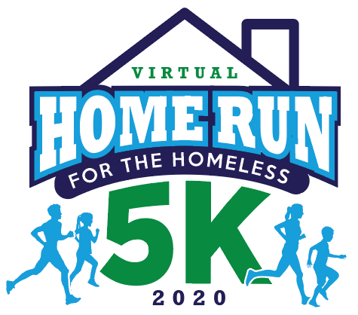
Interested in sponsoring the third annual Home Run for the Homeless? Check out the sponsorship opportunities below and support three local nonprofits; Bridges to Independence, Community Lodgings, and Homestretch.

